EXP NO.2

**DDL Commands with Constraints – PRIMARY, FOREIGN KEY, UNIQUE, CHECK**

Output:

1.

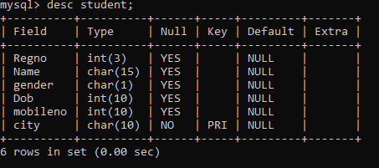

2.

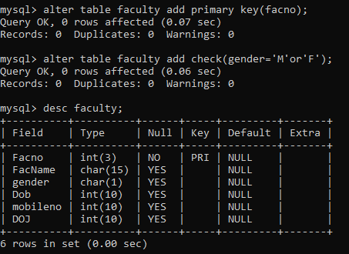

3.

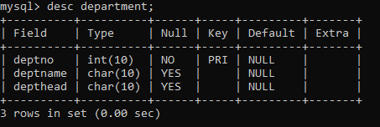

4.

